**ERROR CODE**

**INPUT DATA** :   
Dictionary<string, List<string>>

Key: Cell Name  
 Value: List data of cell

  
**Variables**:

* **List check error code**: Define cells need check error codes:  
  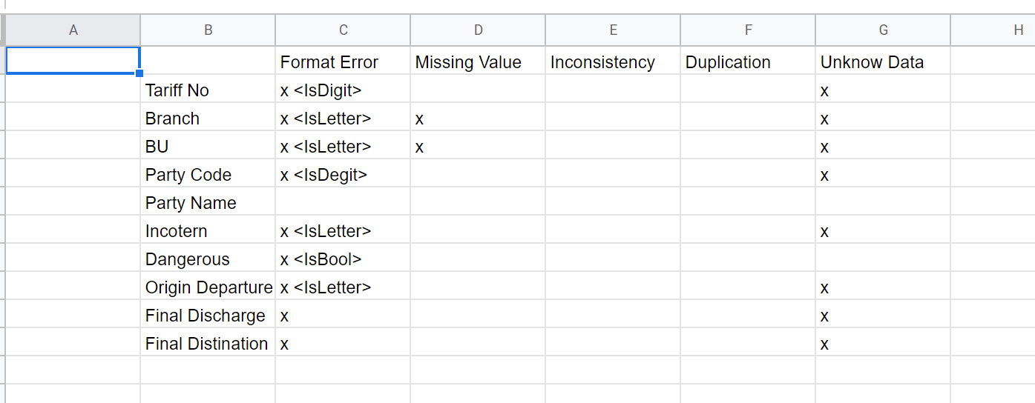  
  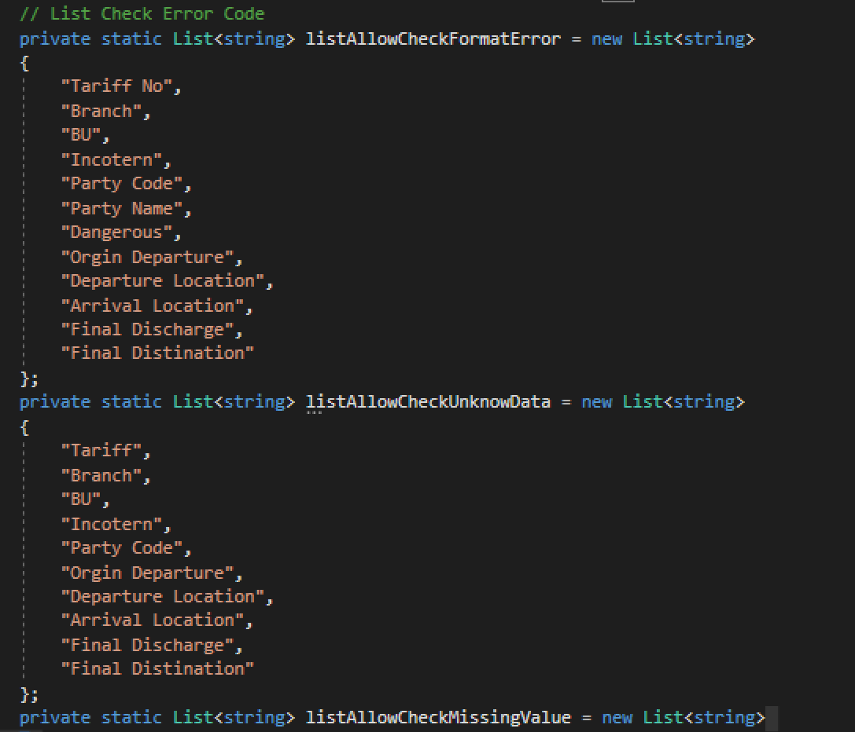
* **List check format error**:   
  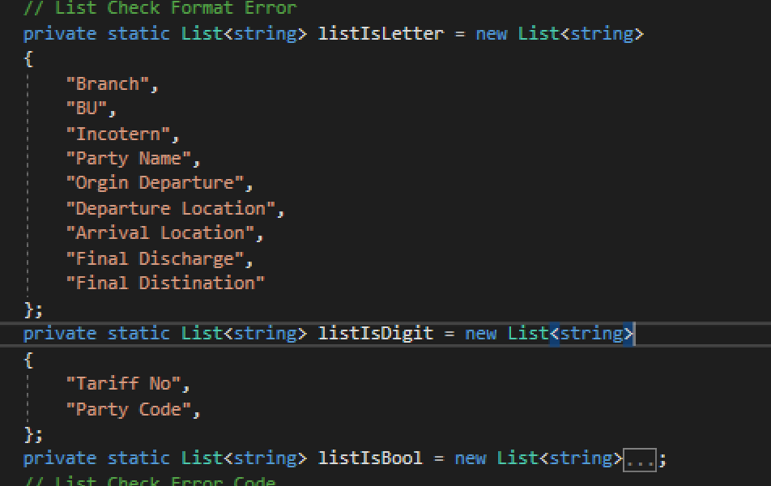
* **Init Data Test**:   
  